Design Document – Group 3

red text defines designed game elements outside the scope of the MVP.

**Game name (undecided): “Decked” / “Ship Happens”**

**Game Logline**

Local coop resource management game where players must coordinate to overcome hazards and manage activities, figuring out the optimal strategy.

**Game Loop**

**Assess** -> **communicate** -> **plan** -> **act**

* Assess: players must focus and react to on screen activity/prompts
* Communicate: players must make their capacity known to reveal options
* Plan: decide which team members are most appropriate to assign to necessary tasks
* Act: players must manage activities/hazards to keep ship afloat

If team survives the level they progress to subsequent levels, earn random rewards.

**Target Demographic**

Male 13-24 (teenagers to young adults).

Networking is not within scope of MVP, if networked demographic expanded to 13 – 35.

**Psychographic**

Male, full-time student, live is student halls, works part time. Social, outgoing, regularly invites friends home.

**Game Platform, Player Input**

Game will be developed for PC, players will use Xbox One controllers to navigate the ship deck.

Development for consoles is not within scope of MVP, but if produced for Xbox and PS4, the games control scheme would be made compatible with the console’s respective controller.

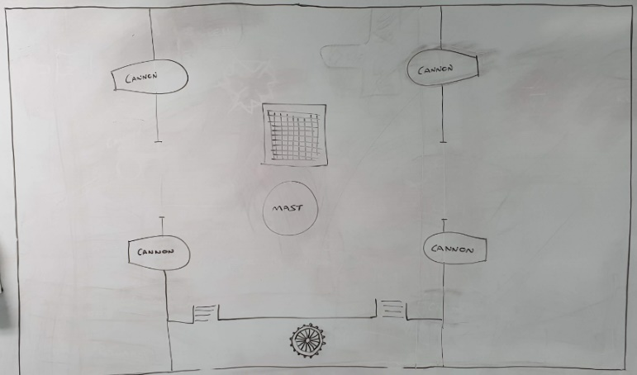**Game Scene**

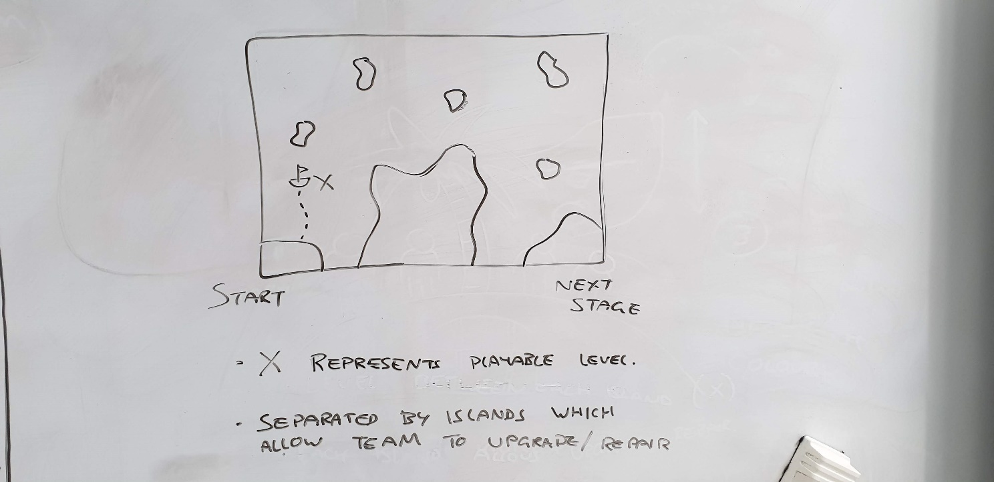**Map Scene**

* Large islands used as obstacles
* Players must complete levels “X” to unlock access to next island
  + Map to show progress, shows player how many levels left in stage
  + Player can replay levels
  + Chose to visit island to upgrade/repair

**UI**

The game level will feature minimal UI.

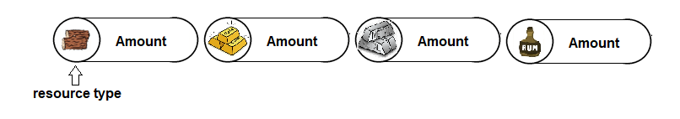On the map screen, the UI will display the hosts profile resources at screen top.

When selecting levels from the map, rectangular ‘treasure-map-style’ brief descriptions will be overlaid next to the current selection. The will indicate the conditions required for level unlock if currently locked, and a brief description of the level.

Game scene UI will feature:

* Cannon contents (attached to each cannon)
  + 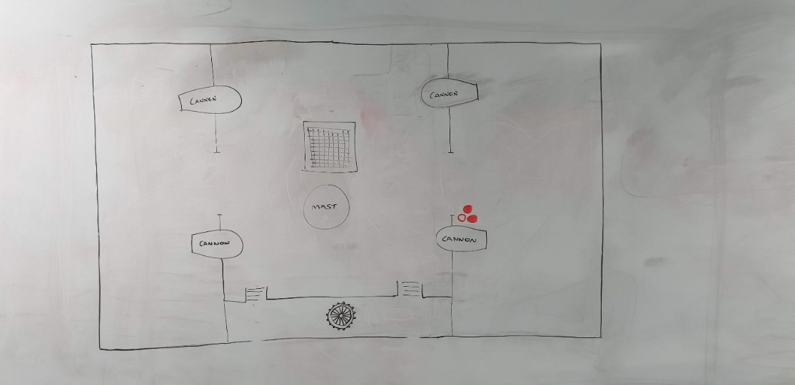Indicates resources cannon requires to be loaded and what is currently loaded
* Crow’s nest indications
  + Crow’s nest speaks in pictures
    - Will be used within tutorial prompts to describe events to players
    - Used to signal hazards to players (hazard and direction of hazard if applicable)

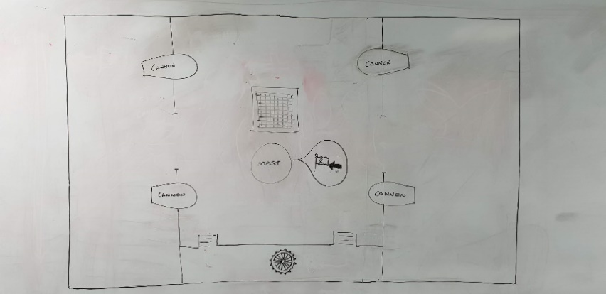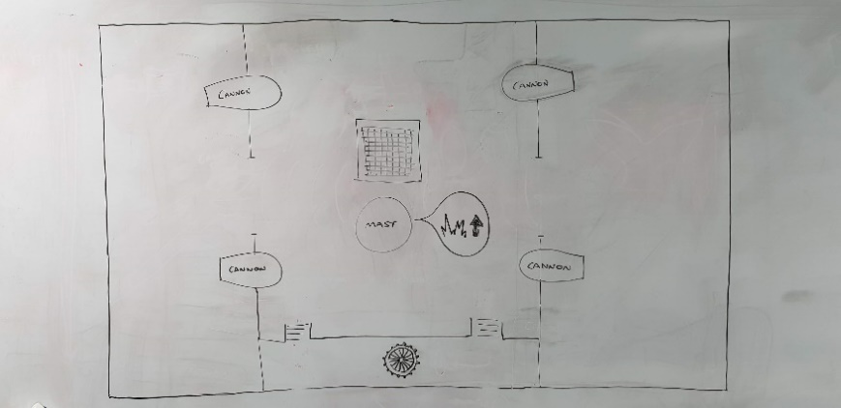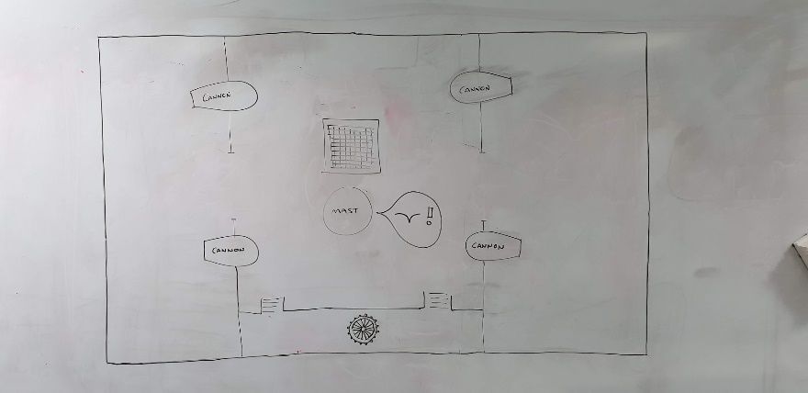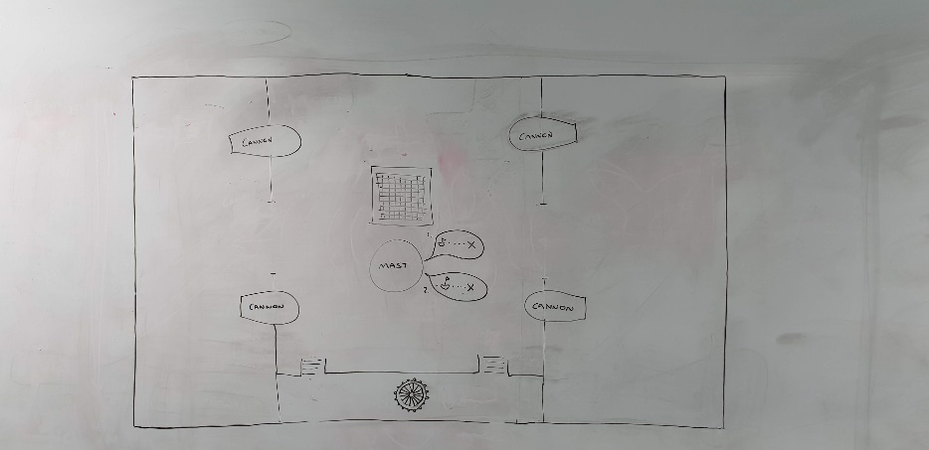

* Ship health
  + Represented by ships flag
  + 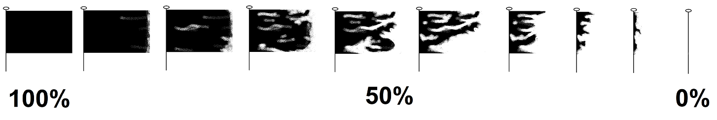Becomes more tattered the closer to lose condition ship becomes
  + Water level on deck will also be descriptive of team’s current survivability

* Distance from level end
  + Numerical values will not be used to represent remaining distance (time) to level end.
  + Visual representations of distance will let players quickly scan the screen
  + 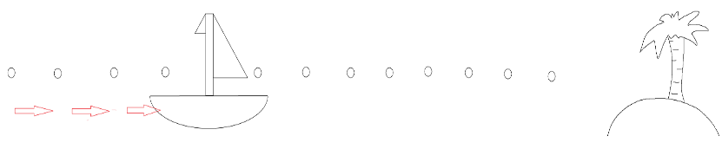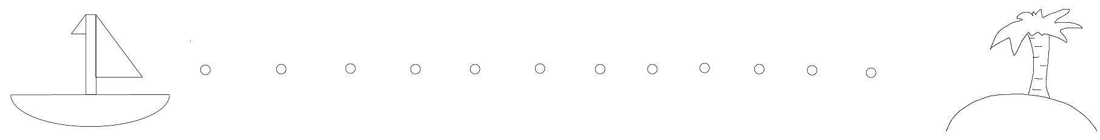
* Using level resources/items
  + Described more thoroughly in ‘mechanics’ section. When player proximity is within set range, the ship hold will show a directional pad which shows which direction corresponds to which resource.
  + 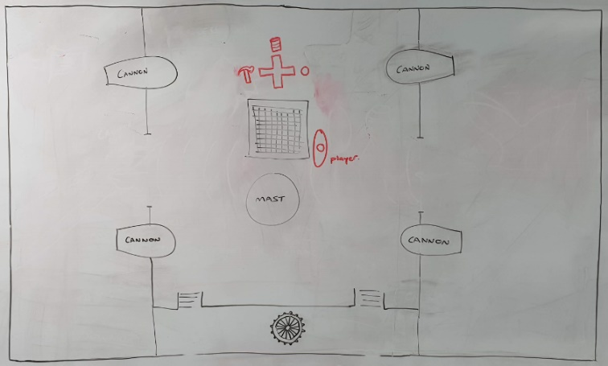This UI element will also show whether a resource is available, or recharging.

**Mechanics**

* **Player movement**:
  + Player must be allowed to move about ship deck. Players will ‘walk’ (slide) along deck surface in direction of controller input. Players do not have ability to jump.
* **Player interactions (explained in greater detail in subsequent bullet points)**:
  + All player interactions are carried out with the intention of repairing damage done to the ship, reducing damage done to the ship, or avoiding damage done to the ship
  + Player must be able to interact with map activities via use of action button(s)
  + Player must be able to use the controller directional pad to retrieve corresponding items from the ship lower deck
  + Player must be able to pick up/use/drop scene tools.
* Flooding and Bail water:
  + As the ship becomes damaged, water will slowly flood the deck while damage is unrepaired.
  + 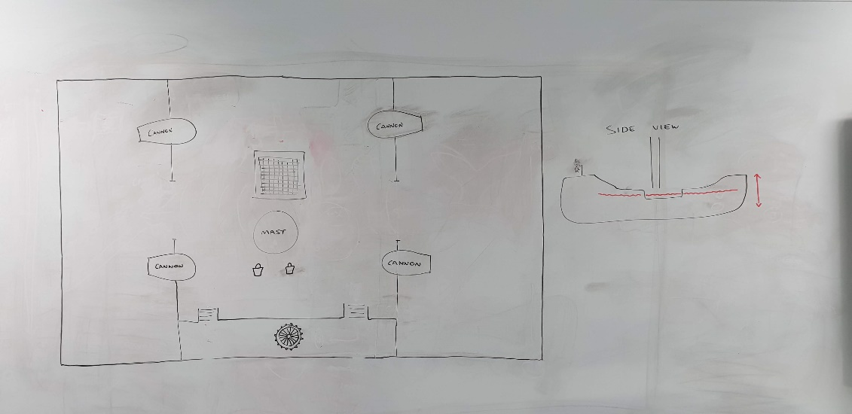The higher the water level, the more friction will be applied to players, slowing their movement.
  + Players can retrieve buckets to bail water from the deck, reducing the rate at which the deck will flood if there is active damage, or reducing the water level if the deck is fully repaired.
  + Bucket can be picked up, used if water on deck, and dropped by the player.
* 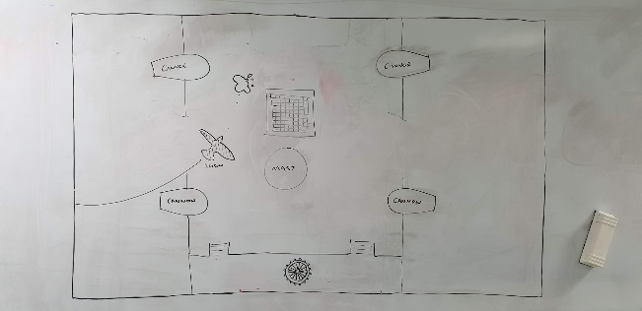Clean deck:
  + Periodically a seagull will fly over the ship deck (only shadow is visible to the players to indicate incoming hazard)
  + Bird poo will be dropped onto the deck, if stepped in players friction will be reduced to give controls an ‘ice-skates’ feel.
  + Players can retrieve mop from the deck, to clean away the mess.
  + Mop can be picked up, used if near mess, and dropped by the player.
* Enemy behaviour:
  + Enemy presence and screen side position will be indicated via Crow’s nest UI
  + Enemy will start at either screen top or bottom (randomly)
  + 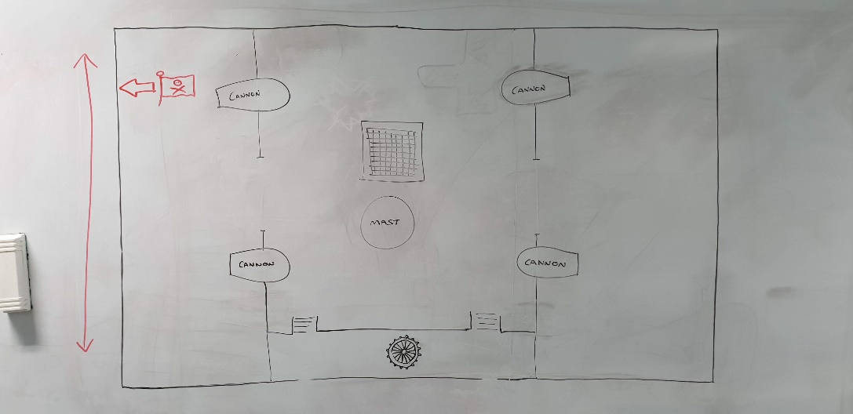If starting from bottom enemy will move upward, if starting top enemy will move downward
  + Flag representing enemy type will indicate relative position of enemy ship
  + Only one cannon can hit an individual enemy ship at any time, the cannon in ‘range’ will throb and pulse with colour when the player is able to fire it to land a successful hit on the enemy
  + 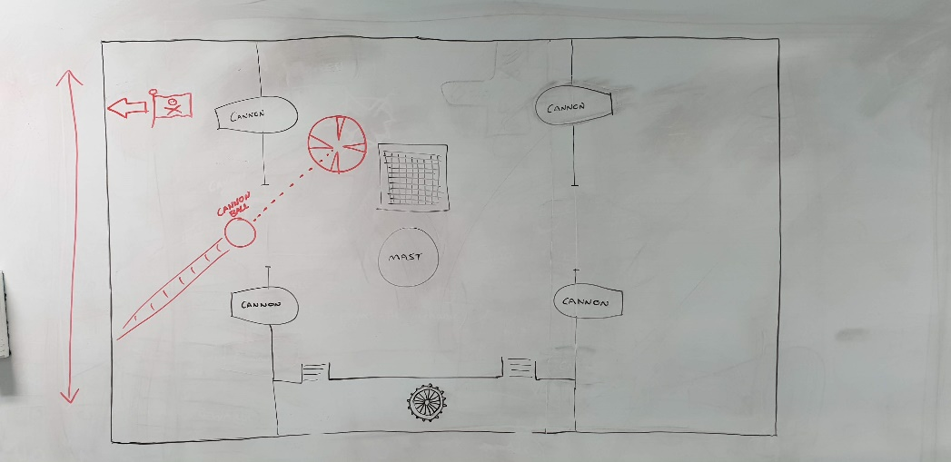If the enemy ship reaches the opposite end of the screen without being damaged, they will fire a cannon ball onto the player deck
  + Players will be given indication of where cannon ball will land with overlaid reticule marker
  + If a player or item is struck by the incoming cannon ball they are knocked from the deck and must respawn
  + Different ships will require the cannons to be loaded with different contents in order to be damaged effectively (different powder types, different ammunition types).
* Player cannons:
  + Cannons will display there ‘loaded contents’ with small UI elements above them
  + UI indicates the ammunition required by the cannons before they can be fired
  + As cannons are loaded, these UI icons will be replaced by the cannons loaded contents
  + To fire a loaded cannon, players must obtain the ‘torch’ item bring it to the cannon, and light the cannon to fire it
  + A loaded cannon can be fired at any time
  + One only cannon will be able to strike an individual enemy at any one time
  + A cannon able to strike an enemy will pulsate/throb and colour shift
  + Fired cannons recoil inward when fired
  + 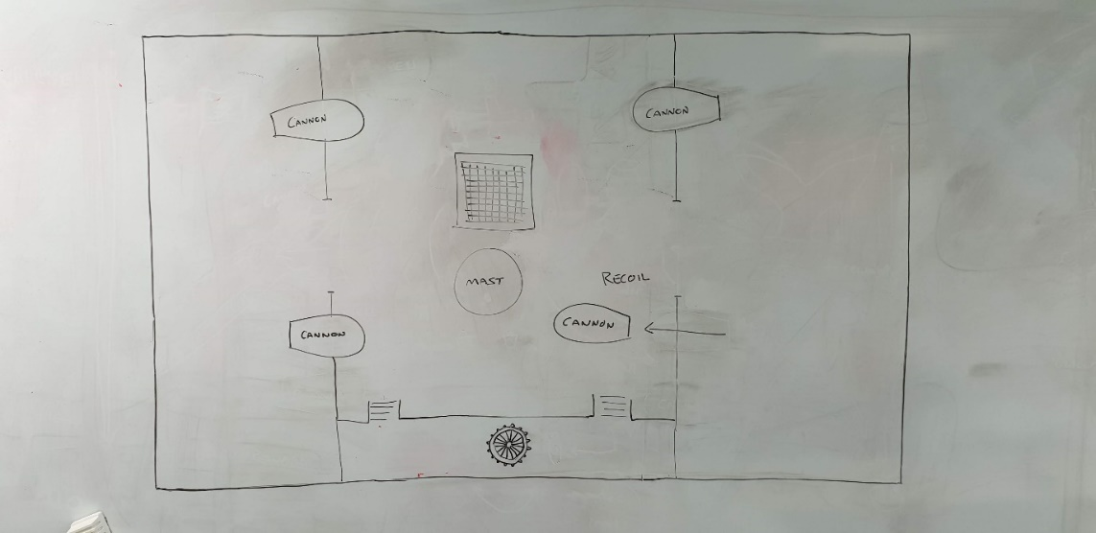Cannons will block pathways around ship and must be pushed back into position by players
  + 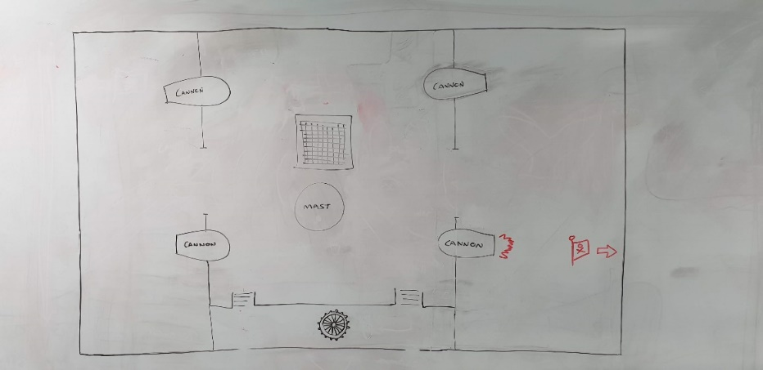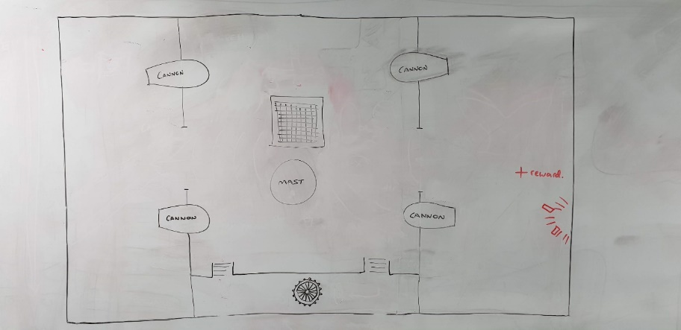Successful cannon hits on enemies will trigger a particle effect to indicate successful action to the player
  + Cannons are upgradable
    - Cannons function will feature as part of ship customisation
    - Rewards will contain variable rewards which can be applied to ship
    - Different cannons would allow choice and player strategies regarding cannon damage, recoil amount, contents, additional contents
* 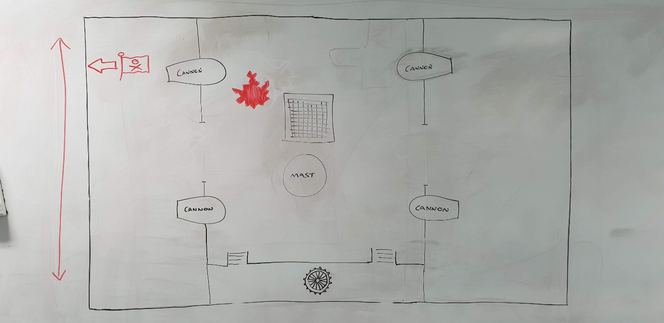Repair deck:
  + Damage caused by enemy cannon fire is repairable by the player through use of the “wood” resource, obtainable from the ship hold (item operates on a recharge timer)
  + Player must obtain wood from hold
  + 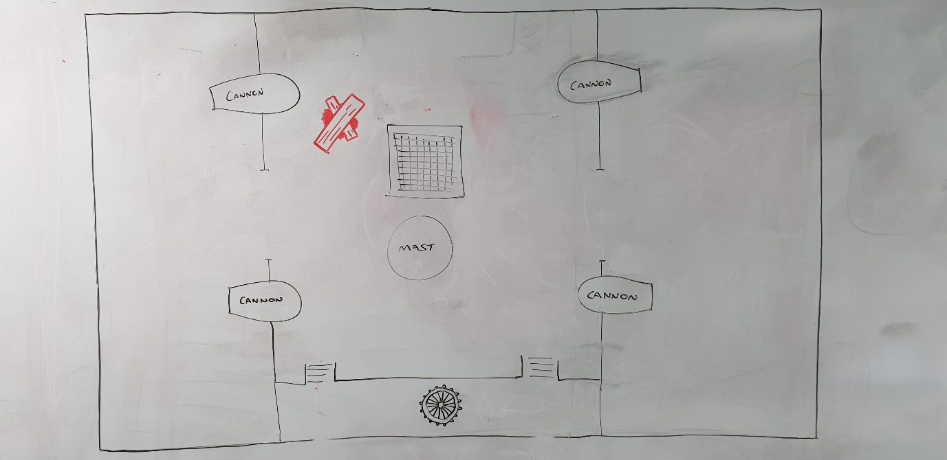Carry wood to damaged area where it is ‘applied’
  + Player must then retrieve hammer item, and use this on a damage area where wood is applied to repair the damage
  + Player can then press action button to begin repair, which will happen over a set time
  + Rate of water fill from this damage will reduce until repair is complete, where this damage will cease contributing to the deck flooding
  + Player-repaired areas are weaker than the decks normal state
* Whale, wave:
  + 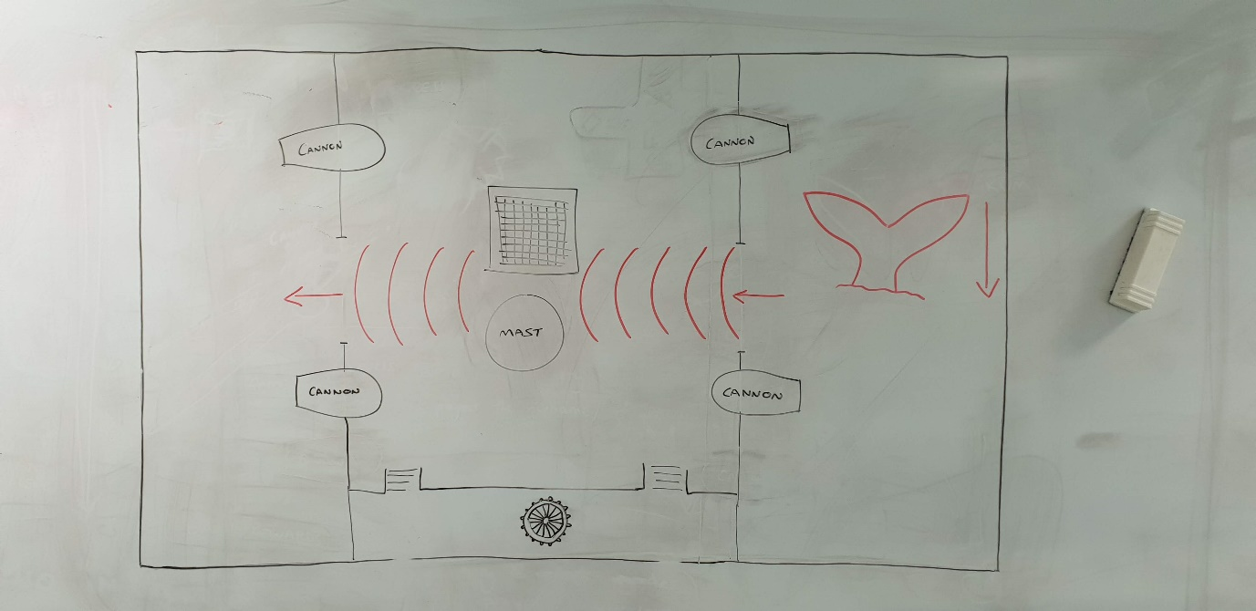To indicate the incoming hazard to players, the whale’s tail will rise from surrounding water, fall back below water level
  + Waves will start from side of ship the whale tail appeared, move towards the ship and across the deck.
  + Waves will wash across the horizontal mid-section of the deck and was any players and dropped items in this zone will be pushed from the ship. Any players or items washed off will be brought back into play after a respawn timer.
* Steer ship:
  + 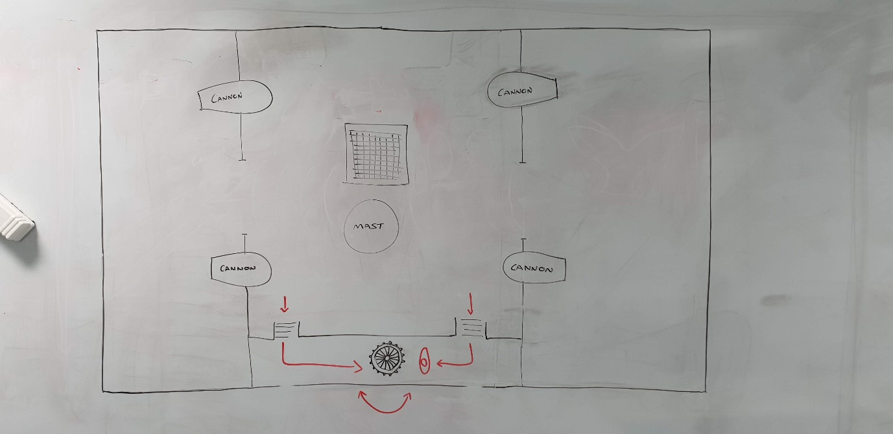The crow’s nest will indicate an obstacle hazard to the player.
  + Players must then move themselves to the ship’s wheel and rotate the thumb stick (either left or right) to move the ship out of the collision path
  + Action will cease after short duration, player will be informed from the crow’s nest that the obstacle is no longer obstructing the ships path
* Retrieve material from hold:
  + Player must walk to opening of hold (players are unable to walk over the top of the hold)
  + 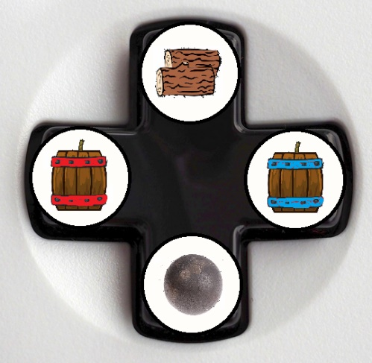When close enough to ship’s hold, UI element will be displayed over the hold opening, indicating which resource corresponds to each direction
  + If obtained, the corresponding icon will be greyed – indicating it is now unavailable
  + The colour of the icon will slowly return, returning in a clockwise rotation

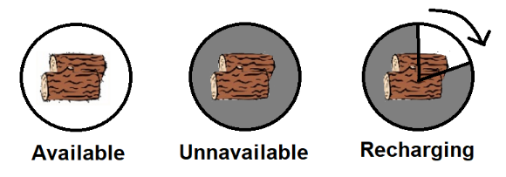

* + When colour has returned, resource is available for use
  + When an enemy ship is destroyed, all recharging resources are immediately made available
* Persistent damage:
  + Incoming cannon fire damages deck
  + This damage is repairable, allowing players to walk over the damaged area and stops further deck flooding
  + Player-repaired damage is permanently weekend
  + The permanently damaged is only repairable by visiting an island port where the option to spend resource to return the deck to normal is available (this repair option is regardless of whether island has shipwright)
  + Player-repaired areas that are within the impact radius of an enemy cannonball, they will become damaged in addition to the new impact damage
* Progression damage:
  + As players advance to later levels of the game, the ship will be damaged in more significant ways which are not repairable by the player
  + 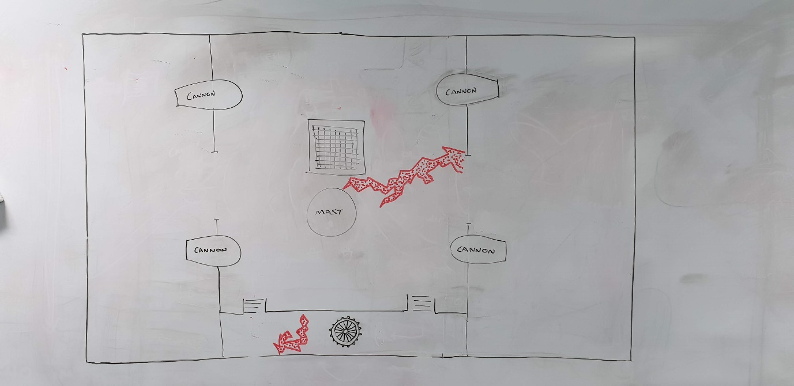This damage restricts navigation of the scene and routes available to players
  + This damage does not contribute towards water level on deck
  + This damage can only be repaired by profile resources by a shipwright at an island port
* Crow nest telegraphing:
  + Speaks in pictures
  + Crow’s nest will appear short (unrealistic height) to remove screen obstruction. This will also give more associated screen space to display multiple UI indications at once.
  + Has ‘pirate accented’ voice lines which will play as pictures are shown
  + Crow’s nest is upgradable
    - Level 1 = says hazard as it happens
    - Level 2 = says direction of hazard as it happens
    - Level 3 = says direction of hazard slightly before it happens
    - Level 4 = gives warning before hazard
* Crew morale:
  + Various voice lines/short sea shanty to give player feedback to reflect successful actions
  + Mumbles and slurs on failed actions
  + Consistent failures lower crew morale, more negative audio, crew moves slower
  + Consistent successes raise crew morale, more positive feedback, crew moves faster
  + Impacts respawn speed of players and items hit by cannon fire/washed overboard

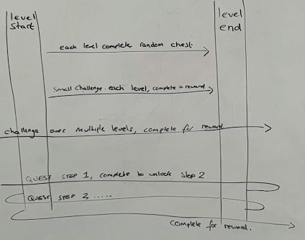

**Rewards:**

* Brown chest: contains profile resources
* Blue chest: contains cosmetic items
* Red chest: contains profile upgrades
* Game will feature several reward schemes
* Player will be rewarded on completion of every level
  + Guaranteed reward chest containing resources will be awarded within a set range based, on team performance and the current stage of the game
  + Chance of reward chest containing cosmetic items
  + Chance of reward chest containing unlockable upgrade
* Player will be rewarded on completion of challenges within single levels
  + If obtained this reward will have a modifying effect on the end of level resources chest
* Players will be rewarded on completion of challenges across multiple levels
  + Random chance of brown and blue chests
* Players will be rewarded on completion of quests (and quest steps) over larger course of game
  + Each step gives chance of brown and blue chests
  + Completion of final step gives guaranteed red chest
* End of level will see players reach the next island, where the earned chest(s) will be shown and opened revealing the player awards

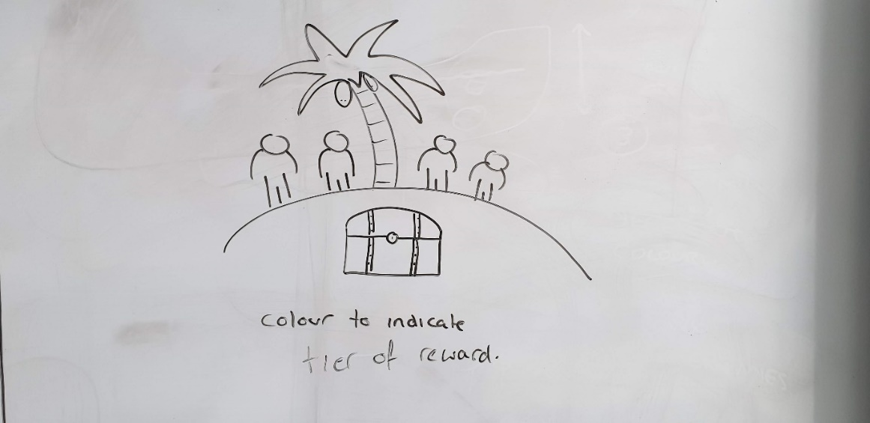

**Resources:**

* In level resources
  + No limit on number of uses
  + If used by a player, the resource becomes unavailable, enters a recharge state and remains unavailable until the recharge has completed.
* Profile resources
  + Persistent resources which accumulate across history of play
  + Wood: used to upgrade and repair
  + Iron: used to upgrade and repair
  + Gold: used to upgrade, repair and buy other resources
  + Rum: used to maintain crew morale
  + Profile resources are earnt by destroying emery ships (small amount), and through chest unlocks (large amount)
* Shop resources
  + If a player unlocks a duplicate customisation option, they will be rewarded with an amount of ‘pieces of eight’, the amount is dependent upon the quality of the duplicate item.
  + Pieces of eight can be used to purchase customisation options directly

**Customisation:**

* Pick ship appearance
  + Ship colour
  + Decals
  + Item colour
* Pick ship outfitting
  + Style of cannon
  + Level of cannon
  + Level of hull
  + Level of storage
* Pick player appearance
  + Select character on game start
    - Clothing variants
    - Hats
    - Peg leg
    - Hand hook
    - Shoulder pet
    - Gold teeth
    - Earring
    - Eyepatch
    - Sword
    - Missing teeth

**Characters**

**Who or what are the characters in the game?**

Characters in the game are crew members.

Players select their characters at the main menu screen.

Players main colour matches their controller number (1 = red, 2 = blue, 3 = green, 4 = yellow).

Guest players have access to the host’s unlocks.

**Assets**

3D assets:

To achieve MVP, minimal visual assets will need to be produced. Team have recognised risk associate with production of models so have identified asset packs which contain models suited to the teams needs and ability. Models contained are untextured, coloured by material and team have sufficient ability to edit existing models if required.

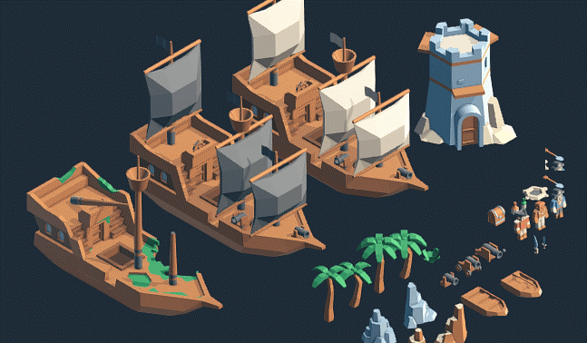

Team are capable of producing remaining 3D assets which are not included within asset pack.

* Included within asset pack:
* Ship
* Cannon ball
* Ship damage variants
* Cannon variants (small to large)
* Treasure chest
* Palm tree
* Characters (will be used for players)
* 3D assets included in pack which team will need to modify:
* Cannon ball impact damage
* Cannon ball deck repair
* Permanent deck damage
* 3D assets team will produce:
* Desert island
* Cargo hatch
* Mop
* Bucket
* Gunpowder barrel
* Whale’s tail
* Customisation options – beyond scope of MVP:
* hook hand
* hats
* shoulder pet (parrot, monkey, toucan, cat, seagull)
* peg leg

Animations:

* cannon throb when enemy within range
* crow’s nest speech bubble
* waving player flag
* Outside of MVP scope:
  + Player emotes
  + Player load cannon
  + Player mop deck
  + Player repair deck
  + Player retrieve material from hold
  + Player washed into sea
  + Player respawn
  + Player successful action, cheer
  + Player unsuccessful action, sulk
  + Chest open at level complete
  + Item reveal and unlock
  + Character emote on player select screen
  + Character equip animation on customisation choice confirmation
  + Treaded path on level select screen
  + Removal of padlock on level select screen

Particle effects:

* Player ship hit with cannon ball, explosion, wood particles
* Enemy ship hit with player cannon, wood particles
* Reward chest contents glow

2D, UI assets:

Skull and crossbones flag (white bones)

Skull and crossbones flag (red bones)

British navy flag

Variants of all flags damage

Resource icons

Images of crow’s nest callouts

UI background panels (treasure map style)

Completion bars to indicate time remaining for each activity

Audio – all beyond scope of MVP:

* Crow’s nest voice lines which correspond to UI callouts
* Crew positive responses
* Crew negative responses
* General background scene noise (waves, wind)
* Hazard and activity corresponding sounds

Textures (does not include material recolour) – all beyond the scope of MVP:

* Character customisation:
  + Clothing (colour variants)
  + Eyepatches (colour variants)
  + Gold teeth
* Ship customisation:
  + Cannon retexture (colour variants)
  + Cannon decal (various options)
  + Sail retexture (colour variants)
  + Deck material (colour variants)
  + Ship wheel retexture (colour variants)
  + Flag decal (various options)

**Full Game Design Overview Flowchart**

Objective / Challenge / Quest Completed

Successfully complete level

Earn Rewards

Load Progress

Player Select / Player + Ship Customisation

New Game

(map) Level Select.

Play Level

(if unlocked) islands on map allow player to repair permanent damage.

(if unlocked) islands with shipwrights allow players to repair permanent damage, progress damage and give option upgrade / customise ship and customise crew.

The next available level, as well as any level previously completed can be selected from the map.

Launch Game

Credits

Options

Main Menu

(map) Level Select.

**MVP Design Overview Flowchart**

Successfully complete level

Player Select / Player + Ship Customisation

New Game

Play Level

Launch Game

Main Menu

Continue to Next Level

**Initial level (tutorial) gameplay**

Tutorial level will drip-feed mechanics to the player.

“Crow’s nest” UI alerts (images within speech bubbles) will indicate how each successive action should be performed. This will guide players through each activity and hazard, showing the visual cues for each hazard and the appropriate response.

The order in which hazards/activities will be introduced to new players will be determined by playtesting later in development, though the style of approach will remain the same.

Playtesting will also reveal whether all hazards/activities will be contained within the first level, or whether some mechanics should be added in subsequent levels to ramp difficulty as the player become more experienced to maintain the pressure of the game.

Level will be loaded

Crow’s nest will display UI warning

Once the warning has been on-screen for 1 second (to give players opportunity to become familiar with the image), the game will pause

Crow’s nest UI speech bubble contents will be replaced with a ‘slide-show’ of images, descriptive of what and how the player must interact with to complete the action

When the ‘slide-show’ is complete, the game will resume

Once introduced, a mechanics ‘slide-show’ will not be shown again. The first hazard will repeat without the addition of any further mechanic 3 times, to familiarise players with the steps required

Further mechanics will be introduced with their own ‘slide-show’, the first time a hazard/activity is introduced, no other hazards/activities will be allowed to trigger, so that players can all focus on the new mechanic and see steps required

Once one instance of the new hazard/activity has been introduced, the game will continue as normal and it will be added to the list of possible hazards/activities to trigger

Instead/in addition to this way of introducing a mechanic, the loading screen can be used to display a single complete image of all stages required to complete a task.

The extra screen space and time (while loading) this can be displayed for may be more easily interpreted by players.

Once play tested approach(es) will be finalised.